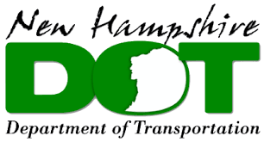

**ACEC-NH/NHDOT Partnering Meeting Agenda**

Friday, June 27, 2025 – 9:00 a.m. to 12:00 p.m.

**NHDOT Headquarters, Concord NH**

**John O. Morton Building, Room 114**

9:00 – 9:30 a.m. – Registration & Networking

**Introductions**: Tobey Reynolds, Assistant Director of Project Development, NHDOT

**Updates & Discussion**

9:30 – 10:00 a.m. – General Annoucements & NHDOT Updates: Tobey Reynolds

* Contracts Sub-Committee Updates: Darren Blood, ACEC-NH
* Highway Design Sub-Committee Update: Jim Marshall, NHDOT Bureau of Highway Design Administrator
* Bridge Design Sub-Committee Update: David Scott, NHDOT Bureau of Bridge Design Administrator

10:00 – 10:15 a.m. – ICR (Indirect Cost Rate) Reconciliation Policy: Tobey Reynolds

10:15 – 10:30 a.m. – Escalation for On-Call Tasks: Tobey Reynolds

10:30 – 11:00 a.m. – Update on Digital Delivery Group

11:00 – 11:40 a.m. – Discussion of the Cross-Section Reallocation Report: Conner Semler, Kittleson

11:40-12:00 a.m. – Open Discussion and Adjournment: Tobey Reynolds

**Upcoming Events**:

Winter Technical Meeting